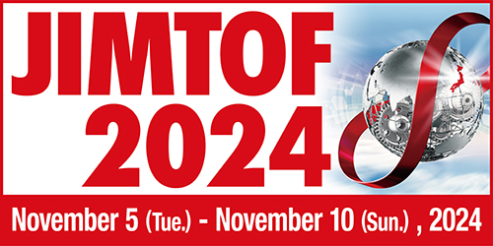

INVITATION FOR PRESS CONFERENCE

AT IMTS 2024

Japan Machine Tool Builders’ Association

Tokyo Big Sight Inc.

Cordially invite you to press conference at IMTS 2024.

Date: Tuesday, September 10, 2024

Time: 14:00 ～15:00

Place: N-426, Media Briefing Room, McCormick Place

Content: Current situation of machine tool industry in Japan

General Information of JIMTOF2024

|  |
| --- |
| Yes, I will attend □  No, I will not attend □ |

|  |  |  |  |
| --- | --- | --- | --- |
| Name | Title | Company | e-mail |
|  |  |  |  |
|  |  |  |  |
|  |  |  |  |
|  |  |  |  |

Please send reply to Ms. Keiko Honda ([honda@jmtba.or.jp](mailto:honda@jmtba.or.jp)). Thank you.